11
Farming Futures: Leveraging Machine Language for Potato Leaf Disease Forecasting and Yield Optimization

A. Vijayalakshmi, A. Nidin, and Deepthi Das
CHRIST (Deemed to be University), Bangalore, India

INTRODUCTION
The intersection of agriculture with technology is not a new phenomenon; throughout history, advancements in farming practices have been closely linked with technological innovations. However, the advent of artificial intelligence (AI) and machine learning (ML) has introduced a transfor- mative wave in agriculture that holds the promise of revolutionizing the way we cultivate, manage, and optimize crop production. Traditionally, agriculture has been shaped by a multitude of factors, including weather conditions, soil quality, water availability, and pest and disease outbreaks. These factors contribute to the inherent uncertainties and challenges faced by farmers, often resulting in resource wastage and reduced yields.
Crop yield prediction is a critical facet of modern agriculture, essential for ensuring food security, optimizing resource allocation, and making informed decisions in the face of dynamic environmental conditions. With the world’s population steadily growing and climate change intro- ducing greater uncertainty into farming practices, the ability to accurately estimate crop yields has become more crucial than ever. Crop yield pre- diction leverages a combination of traditional agricultural knowledge, cutting-edge technology, and data-driven analytics to forecast the likely harvest output of various crops, including staples like wheat, rice, corn, and specialty crops such as fruits and vegetables. This predictive capability empowers farmers, policymakers, and the agricultural industry as a whole

200 DOI: 10.1201/9781003485179-11

to plan effectively, manage resources efficiently, and respond proactively to challenges like pest infestations, disease outbreaks, and adverse weather events. As agriculture increasingly intersects with data science, ML, and remote sensing technologies, the accuracy and sophistication of crop yield prediction models continue to advance, holding the potential to revolu- tionize global food production and foster sustainable farming practices.

LITERATURE REVIEW
With the development of big data technologies and high-performance computers, ML has opened up new possibilities for data-intensive science in the multidisciplinary field of agriculture technology [1]. IBM’s Watson ML API analyzes weather data, Internet of Things (IoT) sensor data, and other sources to provide farmers with tailored recommendations on plant- ing, harvesting, and irrigation. This technology has been used in various regions to enhance agricultural practices [2]. Google Earth Engine uses satellite imagery and ML to monitor deforestation, track land use changes, and assess crop health worldwide, aiding in agricultural and environmen- tal monitoring [3]. The authors here conducted a review of ML applica- tions in agricultural production systems. The research demonstrates how ML technologies will assist agriculture. The authors in [4] conducted a thorough literature review and analyzed various ML algorithms for pre- dicting plant diseases. Various preprocessing techniques on images are also discussed in this work, which proves how automatic detection can help in increasing the yield of crops. A work carried out by [5] proposed an adaptive learning method, which gave an accuracy of 99.2% on the classification of plant leaf diseases for heterogeneous plant data of rice crops. The authors compared the result with other techniques – namely, back-propagation neural network (BPNN), convolutional neural network (CNN), and support vector machine (SVM) and found that the proposed work gives better accuracy. The analysis was done on 40 years’ worth of yield data from 351 German counties by authors in [6] to determine the predominant meteorological and soil hydrological features over four crops. The result of the study proves climatic factors are more important than soil moisture. A literature review conducted on studies that predict crop yield using machine learning algorithms [7] proves that ML algo- rithms are capable of identifying patterns and extracting information

from both structured and unstructured data. The survey also concludes that advanced ML algorithms, like deep-learning methods, have shown they are best at dealing with large amounts of data. The authors in [8] proposed a semi-parametric variant of a deep neural network for data on corn yield from the US Midwest. The results of the model show the nega- tive impacts of climate change on corn yield. In [9], the authors state that there are numerous models for crop classification based on weather, crop disease, growing phase, etc. The authors did a review on various meth- odologies and the accuracy they provide for agricultural yield prediction using AI techniques.
The comprehensive review of the literature presented above unequivo- cally highlights the instrumental role that ML algorithms play in the realm of crop yield prediction and their transformative impact on the agriculture sector. Through a myriad of studies and research endeavors, it becomes abundantly clear that ML algorithms serve as powerful tools capable of harnessing the potential of data-driven insights to revolutionize farming practices. These algorithms have demonstrated their capacity to decipher complex patterns, predict crop yields with remarkable accuracy, and provide invaluable support to farmers in making informed decisions related to planting, cultivation, and resource allocation. Furthermore, their ability to detect and manage crop diseases, optimize resource utili- zation, and adapt to changing environmental conditions underscores their significance in ensuring food security and sustainability in agriculture. In essence, the amalgamation of ML and agriculture offers a promising ave- nue for the future, where technology is leveraged to enhance productivity, mitigate risks, and propel the agricultural sector toward greater efficiency and resilience.

OBJECTIVES AND STRUCTURE OF THE CHAPTER
Potatoes are a staple crop globally, providing a significant portion of the world’s dietary calories. However, they are highly susceptible to various diseases, such as late blight and early blight, which can devastate yields if left unchecked. Detecting diseases on potato leaves is of paramount importance for achieving increased crop yield and ensuring food security. Timely disease detection allows farmers to take proactive measures, such

as targeted pesticide applications or the removal of infected plants, to pre- vent the spread of diseases throughout the field. By identifying and address- ing diseases early, farmers can minimize yield losses, reduce production costs, and maintain the quality of harvested potatoes. Furthermore, dis- ease detection technologies and image analysis enable precise monitoring and management of potato crops, contributing to sustainable agriculture and enhanced global food production.
In this study, the primary focus revolves around the classification of potato leaf diseases. With the ever-growing challenges in agriculture and the imperative need to enhance crop yield and food security, accurately identifying and categorizing diseases affecting potato leaves is of para- mount significance. Through the utilization of advanced techniques in image analysis and ML, we aim to develop a robust classification system capable of discerning various potato leaf diseases. This research not only contributes to early disease detection but also facilitates informed decision- making for farmers, allowing for timely interventions and precise man- agement strategies, ultimately bolstering crop health and yield.

POTATO AS A STAPLE FOOD CROP
Potato, scientifically known as Solanum tuberosum, holds immense sig- nificance as a staple food crop worldwide due to its nutritional value, ver- satility in culinary applications, and capacity to thrive in diverse climates. Understanding the global production of potatoes and their susceptibil- ity to diseases like late blight and early blight is crucial for ensuring food security and addressing the challenges facing potato farming. Potatoes are a rich source of carbohydrates, dietary fiber, vitamins (especially vitamin C and several B vitamins), and essential minerals like potassium and mag- nesium. They provide a substantial portion of daily caloric intake for mil- lions of people around the world. In this study, we have considered potato leaf images that are affected by diseases like late blight and early blight, and using a deep-learning model, we predicted the occurrence of diseases on leaves.

Late Blight:
Late blight is one of the most destructive potato diseases. It manifests as dark-green to black lesions on leaves, often surrounded by a white,



FIGURE 11.1
Late blight disease on potato leaf.

fluffy mold-like growth on the undersides, as shown in Figure 11.1. Infected plants rapidly deteriorate, and the disease can spread rap- idly in cool, humid conditions. Accurate identification of late blight is crucial because it is highly contagious and can lead to significant yield losses if not addressed promptly.
Early Blight:
Early blight primarily affects the lower leaves of potato plants. It pres- ents as circular to irregularly shaped lesions with a dark center and a yellow halo, as shown in Figure 11.2. These lesions can coalesce and lead to extensive defoliation, reducing photosynthesis and tuber qual- ity. Proper classification of early blight helps farmers implement tar- geted control measures, including fungicides and pruning of affected leaves, to limit the disease’s impact on potato yields and tuber quality.
Healthy Leaf:
A healthy potato leaf should have vibrant green coloration without any significant browning, spotting, or lesion, as shown in Figure 11.3. The leaf surface should be smooth and free from abnormal growths or discolorations.

In summary, accurate disease classification in potato crops is a funda- mental aspect of sustainable agriculture, enabling farmers to protect their yields, optimize resource utilization, and contribute to global food security. Farmers and researchers continually work to develop disease- resistant potato varieties and implement sustainable farming techniques

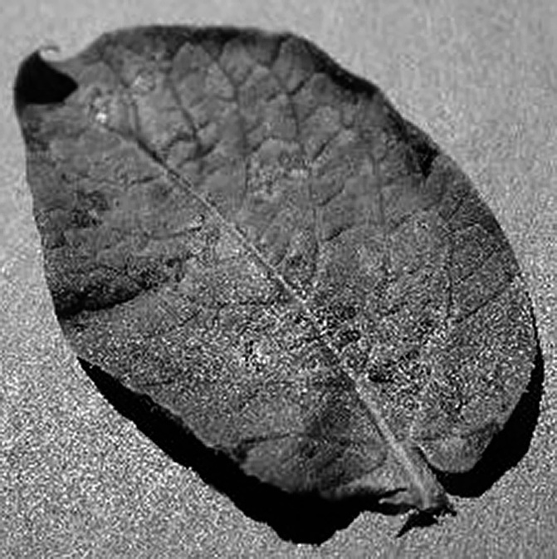

FIGURE 11.2
Early blight disease of potato leaf.


FIGURE 11.3
Healthy potato leaf.

to mitigate the impact of these diseases and ensure the reliability of the potato as a global staple crop.

DATA ACQUISITION AND AUGMENTATION
Potato is one of the most widely cultivated crops in the world, but it is sus- ceptible to various diseases that can significantly reduce crop yield. Early

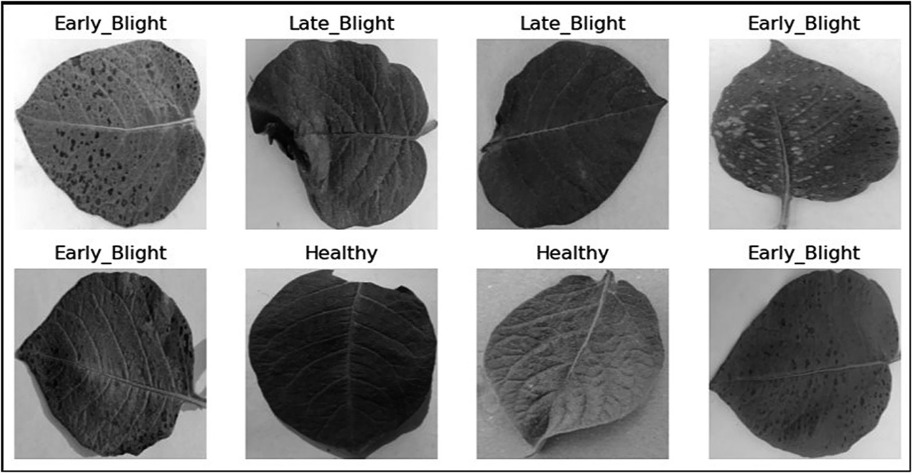

FIGURE 11.4
Sample images from the dataset.

detection and accurate diagnosis of these diseases are crucial for effective disease management. In this chapter, we have considered a case of potato leaf disease that is very common in agriculture. We aim to classify potato leaves using deep-learning techniques for disease detection. We have used the potato leaves images dataset and applied CNNs for classification. A sample of images from the dataset of each category is represented in Figure 11.4.
Various augmentation processes are carried out for the images. Initially, the images are rescaled to a range of [0, 1]. Further, the images are rotated in the range of 30 degrees. Shearing and zoom range are performed by 20%. Width and height wise shift is performed by 5%. The space generated by all these transformations is filled using the nearest neighbor method.

ML MODELS
Crop yield prediction is a critical component of modern agriculture, offer- ing the potential to enhance food security, optimize resource allocation, and mitigate the impact of climate variability. Deep learning, a subset of ML, has emerged as a powerful tool in this domain, capable of transform- ing the way we forecast crop yields. Unlike traditional statistical mod- els, deep-learning models can automatically learn and extract complex

patterns from vast and diverse agricultural datasets, encompassing factors like weather, soil, and historical yield records. Table 11.1 lists various ML models and their properties [10–13]. By leveraging deep neural networks with multiple layers, these models can capture intricate relationships and spatial-temporal dependencies within the data, leading to more accurate and reliable predictions. In this era of increasing demand for food pro- duction and sustainability, deep-learning models for crop yield prediction represent a promising avenue for revolutionizing agricultural practices and ensuring global food security.

TABLE 11.1
List of ML Models in Crop Yield Prediction
Algorithm Advantages Disadvantages

Linear
Regression Logistic
Regression

Decision Trees

Random Forest

Support Vector Machines

K-Nearest Neighbors
Simple and interpretable, works well with linear relationships
Suitable for binary classification Provides probability estimates

Highly interpretable Handles both numerical and
categorical data
Reduces overfitting through ensemble learning
Handles high-dimensional data
Effective in high-dimensional spaces
Can handle nonlinear data with kernel trick
Simple and easy to implement Nonparametric (no assumptions about data distribution)
Limited to linear data, sensitive to outliers and multicollinearity
Assumes linear decision boundaries May not handle complex
relationships well
Prone to overfitting without pruning
Sensitive to small data variations
May be computationally expensive Less interpretable than a single
decision tree
Sensitive to the choice of kernel Can be computationally expensive
for large datasets

Computationally expensive for large datasets
Sensitive to the choice of k

Naive Bayes Efficient and suitable for text
classification
Works well with high- dimensional data
Assumes independence between features (naive assumption)
May not capture complex dependencies

Neural
Networks

K-Means Clustering
High capacity for learning complex patterns
Suitable for deep-learning tasks

Simple and efficient for unsupervised clustering Scales well to large datasets
To train neural network, it needs humongous data
This can be computationally expensive
Requires the specification of the number of clusters (k) Sensitive to initial cluster centroids

    - Convolutional Neural Network
A CNN, also known as ConvNet, is a deep-learning architecture specifi- cally designed for tasks involving image analysis, recognition, and processing. CNNs have revolutionized computer vision and have been ins- trumental in numerous applications, from image classification to object detection. CNNs stand out as a dominant architecture for various rea- sons. Their ability to autonomously extract hierarchical features from data ensures they excel at recognizing patterns and objects within images [14]. CNNs efficiently share parameters across the entire image, mak- ing them computationally effective, especially with large datasets. Their translation-invariant property, along with the inclusion of pooling layers, aids in recognizing objects regardless of their position within an image. In combination with data augmentation and scalability, CNNs have solidified their reputation as superior architectures in image classification [15, 16]. Figure 11.5 depicts the basic architecture of CNN.
The various layers in CNN are explained here.
      - Input Layer: The input layer of a CNN receives the raw pixel values of an image as its input. Typical input images are 2D arrays with three color channels (Red, Green, and Blue).
      - Convolutional Layers: Convolutional layers are the core building blocks of a CNN. They consist of multiple filters (also called kernels) that slide over the input image to extract local features.
      - Activation Function: A nonlinear activation function, such as ReLU (Rectified Linear Unit), is applied element-wise after each convolu- tion process to add nonlinearity to the model. ReLU converts all negative values to zero, aiding the network’s ability to learn intricate, hierarchical features.
      - Pooling Layers: The objective of the pooling layer is to reduce the width and height of the feature map while preserving important information. In a typical pooling technique called max pooling, the
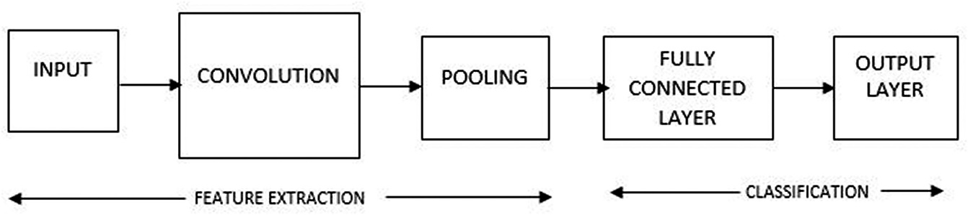
FIGURE 11.5
Architecture of CNN.

maximum value in a particular region of the feature map is kept while the remaining values are discarded.
      - Fully Connected Layers: After several convolutional and pooling layers, the network typically ends with one or more fully connected layers. These layers are densely connected, meaning each neuron in one layer is connected to every neuron in the subsequent layer. Fully connected layers learn high-level features and relationships between the features extracted by earlier layers.
      - Output Layer: The output layer of a CNN depends on the specific task at hand. For image classification, this typically consists of one neuron per class, followed by a SoftMax activation function to con- vert the network’s output into class probabilities.
      - Dropout: Dropout is a regularization technique often applied to fully connected layers to prevent overfitting. During training, a random subset of neurons is “dropped out,” meaning their outputs are set to zero, which helps prevent coadaptation of neurons.
      - Loss Function: The choice of the loss function depends on the prob- lem being solved. For classification tasks, cross-entropy loss is com- monly used, while tasks like regression may use mean squared error.
      - Back Propagation and Optimization: CNNs are trained using back- propagation and optimization algorithms like stochastic gradient descent (SGD) or its variants (e.g., Adam, RMSprop). The network updates its weights and biases during training to minimize the cho- sen loss function.

MODEL ANALYSIS
Understanding the summary of our model is crucial because it provides vital insights into the architecture, parameters, and behavior of the model we’ve developed. By analyzing the model summary, we gain an in-depth understanding of how the data flows through the network, the number of trainable parameters, and the layers involved. This knowledge is essential for troubleshooting and fine-tuning the model’s performance, diagnos- ing issues like overfitting or underfitting, and making informed decisions about optimization techniques. Additionally, model summaries help in communication and collaboration within a team or when sharing research findings, ensuring that others can replicate, evaluate, and build upon our work effectively. Table 11.2 describes the summary of the model.

TABLE 11.2
CNN Model Summary on Potato Leaf Dataset
Layer (Type) | Output Shape | Param #
conv2d (Conv2D) | (None, 254, 254, 32) | 896
max_pooling2d (MaxPooling2D) | (None, 127, 127, 32) | 0
dropout (Dropout) | (None, 127, 127, 32) | 0
conv2d_1 (Conv2D) | (None, 127, 127, 64) | 18496
max_pooling2d_1 (MaxPooling2D) | (None, 63, 63, 64) | 0
dropout_1 (Dropout) | (None, 63, 63, 64) | 0
conv2d_2 (Conv2D) | (None, 63, 63, 64) | 36928
max_pooling2d_2 (MaxPooling2D) | (None, 31, 31, 64) | 0
conv2d_3 (Conv2D) | (None, 31, 31, 64) | 36928
max_pooling2d_3 (MaxPooling2D) | (None, 15, 15, 64) | 0
conv2d_4 (Conv2D) | (None, 15, 15, 64) | 36928
max_pooling2d_4 (MaxPooling2D) | (None, 7, 7, 64) | 0
conv2d_5 (Conv2D) | (None, 7, 7, 64) | 36928
max_pooling2d_5 (MaxPooling2D) | (None, 3, 3, 64) | 0
flatten (Flatten) | (None, 576) | 0
dense (Dense) | (None, 32) | 18464
dense_1 (Dense) | (None, 3) | 99
Total params: 185667 (725.26 KB)
Trainable params: 185667 (725.26 KB)
Nontrainable params: 0 (0.00 Byte)

Conv2D Layer: The model starts with a Conv2D layer with 32 filters, producing an output shape of (none, 254, 254, 32). This is followed by three more Conv2D layers, each with 64 filters. These layers progres- sively reduce the spatial dimensions.
Max-Pooling Layers: Max-pooling layers follow each convolutional layer, reducing the spatial dimensions by half. They help in spatial downsampling and reducing computational complexity.
Dropout Layers: Dropout layers are used after the max-pooling layers. They help prevent overfitting by randomly dropping a fraction of the input units during training.
Flatten Layer: After the last convolutional layer, there is a flatten layer, which reshapes the 3D output tensor into a 1D vector. This is neces- sary to connect the convolutional layers to the dense layers.
Dense Layers: Two dense layers follow the flatten layer. The first dense layer has 32 units, and the second dense layer, serving as the output layer, has 3 units, indicating a multiclass classification task.

Total Parameters: The model has a total of 185,667 parameters, all of which are trainable. The parameter count indicates the capacity of the model to learn and represent complex patterns in the data.
Model Capacity: The model’s capacity seems adequate for a moderate- sized dataset with three output classes. The 32 units in the first dense layer provide a reasonable level of complexity.
This CNN architecture is used for a multiclass classification task with three classes. It has a reasonable number of parameters and includes essential components like convolutional layers, max-pooling layers, drop- out for regularization, and dense layers for classification.

RESULTS AND DISCUSSIONS
In this section, we present the results of our study in potato leaf disease classification using CNNs. The outcomes of our experiments not only vali- date the efficacy of this ML approach but also shed light on its potential to revolutionize the field of agricultural disease management. Through rigor- ous testing and analysis, we have uncovered valuable insights that under- score the significance of our research in enhancing crop yield prediction and, more broadly, in addressing critical challenges in agriculture.
The dataset under study included three folders each for training, testing, and validation. Each of the folders included potato leaf images of all three categories – namely, early blight, late blight, and healthy. For training, we have considered 300 images of early blight, healthy, and late blight potato leaves. One hundred images for testing and 100 for validation. Table 11.3 shows the loss and accuracy of the model.
The training and validation accuracy and loss graphs, depicted in Figure 11.6, serve as vital visual representations of our model’s performance throughout the training process. The training accuracy, 0.9856, represents

TABLE 11.3
Loss and Accuracy of the Model

Training
Training
Validation
Validation
Test

Loss | Accuracy | Loss | Accuracy | Test Loss | Accuracy
0.0470 | 0.9856 | 0.0433 | 0.9965 | 0.0757 | 0.9741

212 • Data-Driven Farming

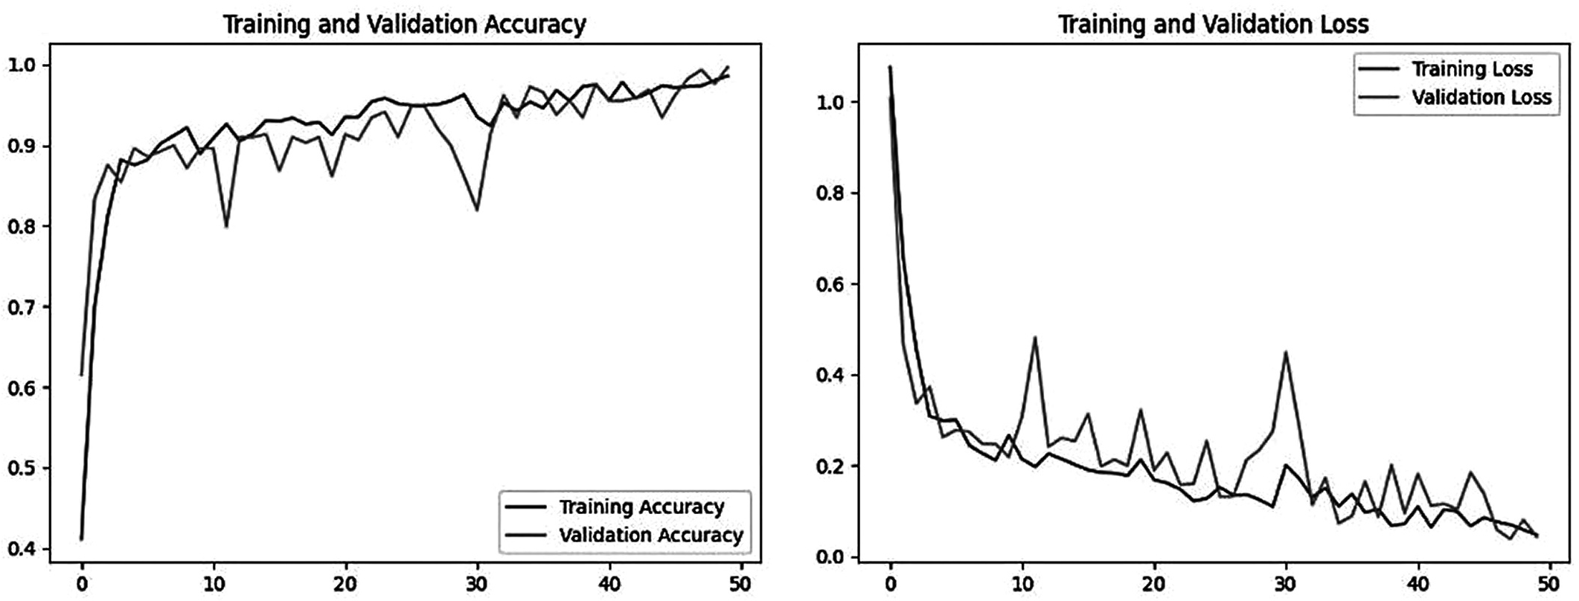

FIGURE 11.6
Training and validation graphs.

the percentage of correctly classified instances within the training dataset as the model learns and adapts.
Simultaneously, the training loss, 0.0470, represents the magnitude of errors made by the model during training. Lower values signify that the model’s predictions align more closely with the actual ground truth labels. On the validation side, we see similar trends. The validation accuracy, 0.9965, shows how well our model generalizes to unseen data, specifically
the validation dataset.
In parallel, the validation loss, 0.0433, reflects the model’s performance on this separate dataset. As with the training loss, we aim for this value to decrease during training, indicating that the model is not overfitting to the training data but is learning to make more accurate predictions on new, previously unseen data.
The test results provided, including a test loss of 0.0757 and a test accu- racy of approximately 97.42%, offer valuable insights into the performance of the CNN model.
- Test Loss (0.0757):
The test loss is a crucial metric for assessing the model’s predictive accuracy. In this case, the test loss is exceptionally low, indicating that the model’s predictions are very close to the actual values in the test dataset. A low test loss suggests that the model has effectively learned the underlying patterns and features in the data, enabling it to make accurate predictions.
- Test Accuracy (97.42%):
Test accuracy measures the proportion of correctly classified examples in the test dataset. With an accuracy of approximately 97.42%, the model is performing exceptionally well. An accuracy rate of over 97% suggests that the model is well-suited for the classification task at hand.
- Model Generalization:
The impressive test accuracy and low test loss reflect the model’s strong generalization capabilities. It is not overfitting the training data, as it can make accurate predictions on new, unseen samples.
- Model Reliability:
The high test accuracy and low test loss indicate that the model is reliable and consistent in its predictions.
The test results of the model, with a test loss of 0.0757 and a test accuracy of approximately 97.42%, demonstrate that the model has successfully learned

214 • Data-Driven Farming

and generalized patterns from the training data. These results suggest that the model is well-suited for the classification task it was designed for.

CONCLUSION
In conclusion, this study has demonstrated the effectiveness of CNNs in the classification of potato leaf disease, achieving remarkable results with a test loss of 0.0757 and a test accuracy of 0.9741. These findings underscore the potential of ML techniques in agricultural applications, specifically in the early detection and management of plant diseases. By harnessing the power of CNNs, we have paved the way for more accurate and timely identification of potato leaf diseases, enabling farmers to take proactive measures to protect their crops and optimize yields. This research not only contributes to the field of precision agriculture but also holds promise for addressing global food security challenges by improving crop health monitoring and management. As technology continues to evolve, further advancements in ML can lead to even more robust tools for agricultural sustainability and productivity.

REFERENCES
- Liakos, Konstantinos G., et al. “Machine learning in agriculture: A review.” Sensors
18.8 (2018): 2674.
- Jain, Ashriti, et al. “Agro-inundation for maximizing crop yield and water efficiency.”
SSGM Journal of Science and Engineering 1.1 (2023): 10–14.
- Shelestov, Andrii, et al. “Exploring Google Earth Engine platform for big data process- ing: Classification of multi-temporal satellite imagery for crop mapping.” Frontiers in Earth Science 5 (2017): 17.
- Ushadevi, G. “A survey on plant disease prediction using machine learning and deep learning techniques.” Inteligencia Artificial 23.65 (2020): 136–154.
- Patel, Bharati, and Aakanksha Sharaff. “Rice crop disease prediction using machine learning technique.” International Journal of Agricultural and Environmental Information Systems (IJAEIS) 12.4 (2021): 1–15.
- Lischeid, Gunnar, et al. “Machine learning in crop yield modelling: A powerful tool, but no surrogate for science.” Agricultural and Forest Meteorology 312 (2022): 108698.
- Bali, Nishu, and Anshu Singla. “Emerging trends in machine learning to predict crop yield and study its influential factors: A survey.” Archives of Computational Methods in Engineering 29 (2022): 1–18.

- Crane-Droesch, Andrew. “Machine learning methods for crop yield prediction and climate change impact assessment in agriculture.” Environmental Research Letters
13.11 (2018): 114003.
- Reddy, D. Jayanarayana, and M. Rudra Kumar. “Crop yield prediction using machine learning algorithm.” 2021 5th International Conference on Intelligent Computing and Control Systems (ICICCS). IEEE, 2021.
- Alzubi, Jafar, Anand Nayyar, and Akshi Kumar. “Machine learning from theory to algorithms: An overview.” Journal of physics: Conference Series. Vol. 1142. IOP Publishing, 2018.
- Kaur, Sunpreet, and Sonika Jindal. “A survey on machine learning algorithms.” International Journal of Innovative Research in Advanced Engineering (IJIRAE) 3.11 (2016): 2349–2763.
- Das, Kajaree, and Rabi Narayan Behera. “A survey on machine learning: Concept, algorithms and applications.” International Journal of Innovative Research in Computer and Communication Engineering 5.2 (2017): 1301–1309.
- Mahesh, Batta. “Machine learning algorithms - A review.” International Journal of Science and Research (IJSR) 9.1 (2020): 381–386.
- Li, Zewen, et al. “A survey of convolutional neural networks: Analysis, applications, and prospects.” IEEE Transactions on Neural Networks and Learning Systems 33 (2021): 1–21.
- O’Shea, Keiron, and Ryan Nash. “An introduction to convolutional neural networks.” arXiv preprint arXiv:1511.08458 (2015).
- Albawi, Saad, Tareq Abed Mohammed, and Saad Al-Zawi. “Understanding of a convolutional neural network.” 2017 International Conference on Engineering and Technology (ICET). IEEE, 2017.

